**FACULTY OF ENGINEERING AND APPLIED SCIENCE**



|  |
| --- |
| **SOFE 3490U - Software Project Management**  **Lab 4 Report**  **Group**  **Monday, March 25, 2019** |

|  |  |  |  |
| --- | --- | --- | --- |
| **MEMBERS** | | | |
| **#** | **Last Name** | **First Name** | **Student ID** |
| **1** | Mobassher | Nafis | 100587562 |
| **2** | Chowdhury | Muhtasim | 100584755 |
| **3** | Shahriyar | Sakib | 100587434 |

One risk that we could potentially encounter at the start of our project is the lack of experienced developers. Since this is our first project, we will probably make some mistakes which can lead to failure. A way to avoid or mitigate this risk is to hire an experienced project manager that has worked with a lot of developers at once. Since this project is very large, we will require many developers to work together in order to complete it in an efficient manner. Our project manager needs to also keep everyone motivated as a lack of motivation can cause other members of the team to have to work harder than what is required. The project manager needs to distribute the work to all members based on their experience level and have strict deadlines so that they can get their work done as soon as possible and have more time to focus on customer needs and satisfaction.

Another risk could be the lack or the abundance of personnel. Both of these factors can affect the way the project is made because if there is a lack of developers working on the project, the deadlines would need to be extended and the project would take a much longer time to complete. However, if we have too many developers, we may have some not working enough for us to utilize them. We do not need to hire extra employees if they are not required at this moment. Ways to mitigate this problem is to make sure we have enough developers for each section of our project and that they work efficient enough to finish their part by their required deadlines. We will assign each developer a specific task to complete, and based on what they do and long it takes, we can add more tasks for them to do.

Finally, when the project is complete, a risk that could occur is customer dissatisfaction. To mitigate this risk, we will develop prototypes and ask for customer feedback. We will release a beta version of our software and have customers write reviews on it. With the reviews, we will make changes accordingly. With customer support, we will be able to find defects earlier and will be able to fix them before they cause more issues. This will reduce time and costs for our software and increase the overall satisfaction for the customers when the final software is released.

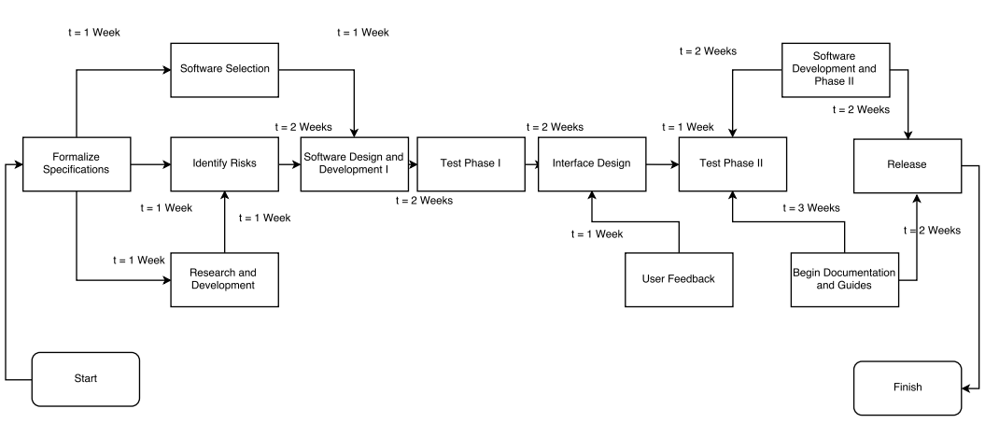

For this project, we will have 3 teams. The three teams are Systems Analyst team, Development team, and SQA team. The systems analyst team will have one team lead who will guide the rest of the analysts and assign them tasks. The development team will have a main lead and multiple developers working under the lead’s management. The development team will also have people who specialize in front end and people who specialize in back end work. Lastly, the SQA team will have a quality assurance lead and a few quality assurance analysts working under their leadership.

|  |  |
| --- | --- |
| **Task** | **Team(s) responsible** |
| Formalize Specifications | System analyst team |
| Software Selection | System analyst team and Development team |
| Identify Risks | System analyst team and SQA team |
| Research and Development | Development team |
| Software Design and Development I | Development team |
| Test Phase I | SQA team |
| Interface Design | Development team |
| User Feedback | Development team and SQA team |
| Software Design and Development II | Development team |
| Documentation and Guides | System analyst team |
| Test Phase II | SQA team |
| Release | Development team |